The Slough Nursery Schools Network SNSN invites you to attend our Early Years Conference, led by Denise Kilner and Kay Rooks:-

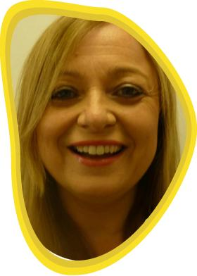 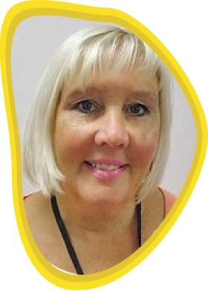

Denise has a wide experience of teaching and management having begun her teaching in Key Stage 2 then moving into Key Stage 1; this was followed by several years teaching in both Reception and Nursery. Denise has also worked as an Early Years Support Teacher and a Foundation Stage Leader. She was the Deputy Headteacher of a large infant school then, for 5 years was the Headteacher of Mill Hill Nursery School in Sunderland. Denise then worked for the University of Sunderland as an Academic Tutor and as Learning and Teaching Adviser for Focus on Learning, a CPD centre in the North East of England. For a year Denise worked for Early Excellence on their National Team where she researched and co-authored The Hundred Review- a national review of the Reception year.

Recently, Denise has returned to Nursery School Headship and is now the Headteacher at Bensham Grove Nursery School in Gateshead.

Denise has been a committee member of the Sunderland Early Education branch for 13 years.

Denise has a personal interest in creating enabling environments, documenting children’s learning, developing thinking and supporting creativity.

Kay has a wide experience of teaching and management within the field of Early Years and Key Stage One. She has several years of teaching experiences within nursery, infant and primary school and has leadership experience as a SENCO, Deputy and Acting Head teacher. Kay has had experience of working on the delivery of projects including the ‘Talk, Talk’ project with Sunderland Learning Support Service and Early Years innovative projects as the Early Years Consultant for Sunderland Education Action Zone.

For twelve years Kay has worked as an Early Years Adviser for Hartlepool Local Authority and later Sunderland Local Authority where she managed teams of consultants and support teachers and worked across teams of school improvement and childcare professionals, as part of the Sure Start and Children’s Centre agendas. This provided many opportunities to work with childminders, settings and schools and involved statutory and project work.

More recently Kay has moved to work as a Learning and Teaching Adviser for Focus on Learning, a CPD centre in the North East of England and is an Academic Tutor at the University of Sunderland.

She has been a member of Early Education for many years and is currently Chair of the Sunderland branch committee.

In 2017 Kay moved to become one of the three Directors of Castle Kindergarten and in September 2017 opened the doors to three private day nurseries: Albany and Hylton Castle in Sunderland LA and Sacriston in Durham LA. The nurseries take fee paying children from Birth to Four years and disadvantaged two years old children and 30 hours’ children. We work in close partnership with the three feeder primary schools to offer a flexible service. This new opportunity allows Kay to work with children, practitioners and families across the three settings and to monitor and develop practice.

Kay has a personal interest in creating enabling learning environments for children, particularly in the areas of personal, social and emotional development and in developing children’s language, communication and early literacy skills. She is also interested in the areas of sustained shared thinking and supporting creativity.

**Topics covered during the conference:**

Why a learning environment is so important

What our learning environments say about our view of the learner

How a learning environment can support a child’s learning and development

The environment as the ‘third teacher’

Creating an enabling environment-what should we consider

The importance of light and colour

Resources that will stimulate learning in our environments -open ended and stimulating

The adult role within the environment and how this relationship can extend and challenge learning.

Venue – Stoke Place, Stoke Green, Slough, SL2 4HT

8:30am-9:00am Arrival tea and coffee including pastries

9:00am Conference starts

10:15am-10:35am Mid-morning tea and coffee with muffins

12:00pm-1:00pm Lunch – Please advise any dietary requirements

2:00pm-2:20pm Mid-afternoon tea and coffee with cake

3:30pm Conference ends

Cost £85. If you would like to join us for this inspirational day, please contact Sarah Halsey on **01628 661506** or email **bursar@cns.slough.sch.uk**